Miami Dolphins Record Breaking Day
Brandon Selway
Editor: NFL Weekly
Weekly contributor NFL Fantasy recap

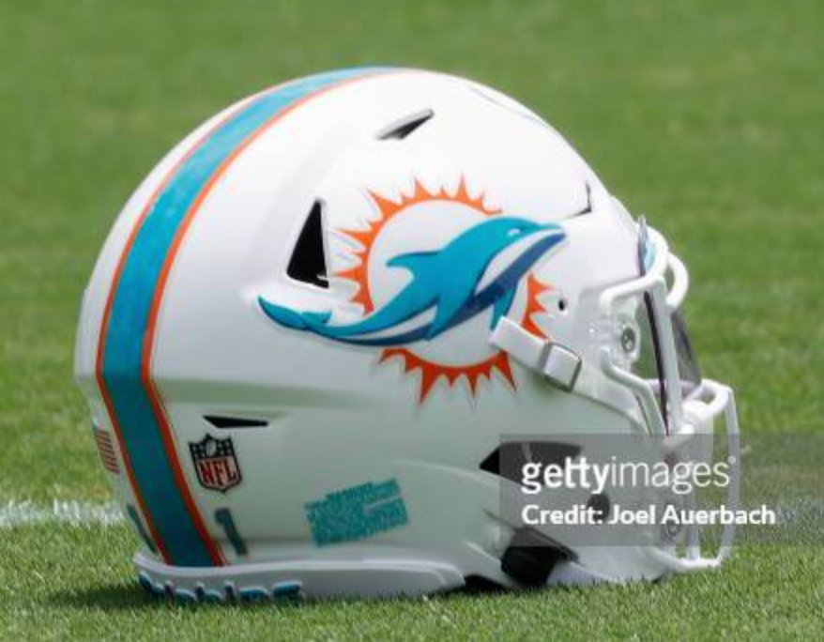
On Sunday, September 24, 2023, the Miami Dolphins scored a record-breaking 70 points against the Denver Broncos, resulting in a 70-20 score. This game recorded the third highest point total of all time and the most since the then Washington Redskins scored 72 points against the New York Giants in 1966.The Dolphins averaged 10.2 yards per play which amassed to over 700 yards of total offense which is the most since the Rams did so in 1951. The Dolphins are the first to record five rushing and passing touchdowns in a single NFL game and the second to record 300 rushing and passing yards. Miami’s running back duo Raheem Mostert and De’Vone Achane are the first pair of teammates to score four non passing touchdowns in the same game. The Miami Dolphins have started 3-0 in back to back seasons under Head Coach Mike McDaniel. They will take their undefeated season into Buffalo in an AFC East game against the Bills.

