CJ Stroud Leads Comeback In Closing Seconds
Brandon Selway
Editor: NFL Weekly
Weekly contributor NFL Fantasy recap
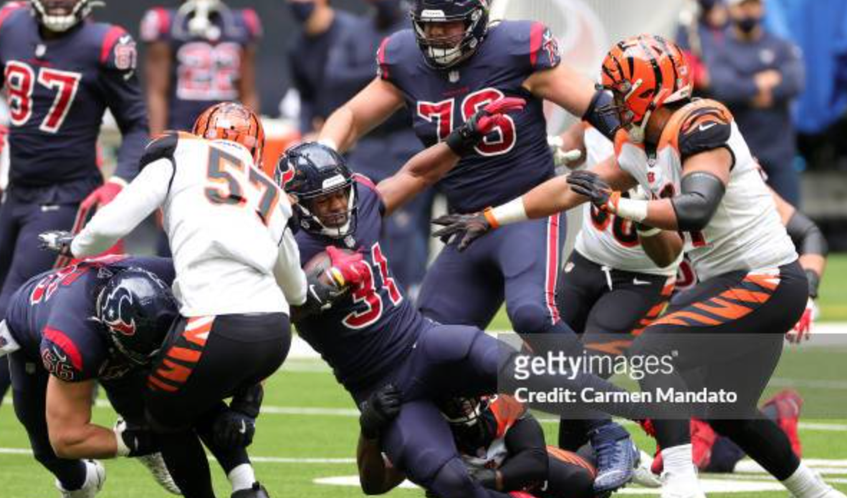
The No. 2 overall pick tore the Buccaneers defense apart in his eighth career start, tying a rookie record with five touchdown passes and setting one with 470 passing yards during a performance that included a climactic, game-winning drive to steal a 39-37 victory over the Tampa Bay Buccaneers.Three Texans’ receivers went over 100 yards as Houston had 496 total yards. Noah Brown had six catches for 153 yards and a touchdown, Dalton Schultz 10 catches for 130 yards and one touchdown and Dell six for 114 yards and two touchdowns.Houston moved to 4-4 with two of their losses coming on last-play field goals. Tampa Bay lost its fourth in a row to fall to 3-5. The Buccaneers look to bounce back on Sunday November 12th against the Tennessee Titans. Meanwhile, the Texans look to keep their wins rolling against the Cincinnati Bengals.

