Josh Dobbs Leads Vikings Past Saints
Brandon Selway
Editor: NFL Weekly
Weekly contributor NFL Fantasy recap

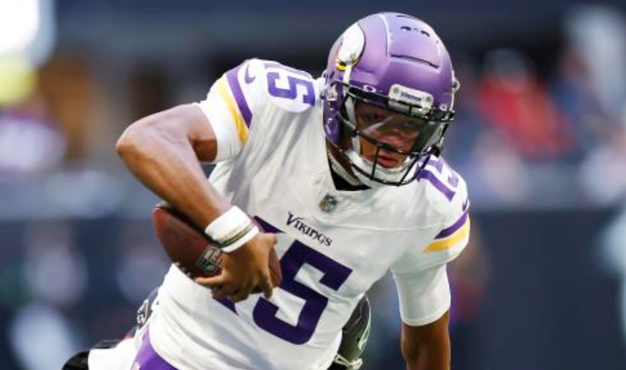
Josh Dobbs kept an injury-thinned offense on track in his first start, throwing for a career-high 268 yards and contributing two touchdowns to help the Vikings build a 24-point halftime lead and hold on to beat the New Orleans Saints 27-19 on Sunday for their fifth straight victory. T.J. Hockenson outgained the Saints by himself in the first half with 10 catches for 128 yards and a score for the Vikings. After Derek Carr was forced out in the third quarter with a concussion and a shoulder injury, Jameis Winston entered with a 27-3 deficit and delivered touchdown passes to Chris Olave and A.T. Perry on highlight-reel, high-degree-of-difficulty catches in the end zone over Byron Murphy. Mekhi Blackmon and Byron Murphy had fourth-quarter interceptions of downfield heaves by Jameis Winston that ended consecutive Saints possessions, and Winston's last-chance throw into a crowd in the end zone on the final play was knocked safely to the turf. The saints have a bye week next week to reflect on the loss and get healthy. Meanwhile the Vikings play the Denver Broncos next Sunday.

