Jake Moody Misses Game Winning Field Goal
Brandon Selway
Editor: NFL Weekly
Weekly contributor NFL Fantasy recap
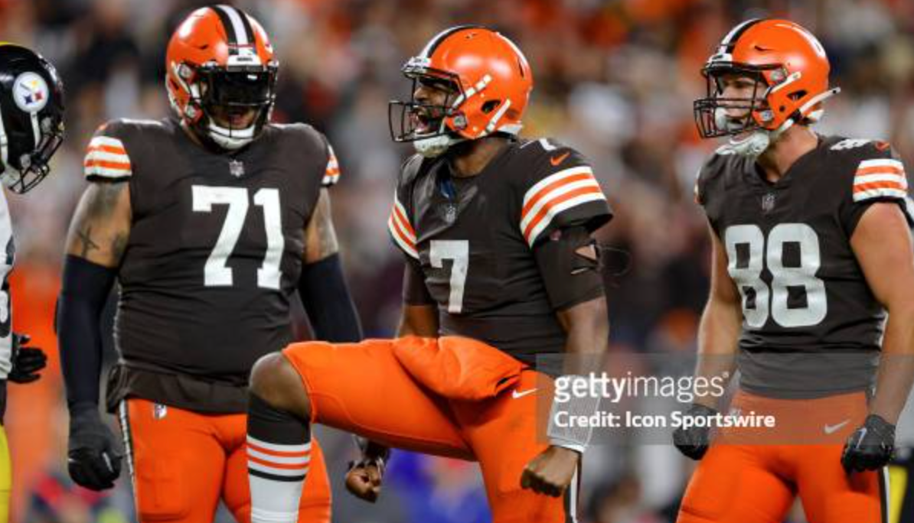
Kicker Jake Moody missed a 41 yard field goal with six seconds left in regulation to give the Cleveland Browns a 19-17 victory over the San Francisco 49ers. “It’s on me,” said Moody, who also missed from 54-yards in the first half. "I’ve got to make these kicks in these situations. That’s what I signed up for at my position. The team fought really hard to give me a chance."It was a perfect snap, perfect hold. I just didn’t hit it the way I wanted to”. Quarterback Brock Purdy completed just 12 of 27 pass attempts for 125 yards with one touchdown pass, one interception and a passer rating of 55.3 against the Browns. This is Brock Purdys first loss in the regular season since becoming a starting quarterback last season. The 49ers fall to 5-1 on the season but remain at the top of the NFC, along with the Philadelphia Eagles and Detroit Lions. Cleveland pulled off the upset without quarterback Deshaun Watson, who missed his second straight game with a bruised right shoulder. Cleveland’s top-ranked defense was more than up to the task, and the 49ers were short-handed in the second half without playmakers Christian McCaffrey and Deebo Samuel, both who left with injuries. Cleveland looks to keep the momentum rolling on October 22nd when they take on the Indianapolis Colts.The 49ers look to bounce back against the Minnesota Vikings on October 23rd.

