Nick Chubb Out For Season
Brandon Selway
Editor: NFL Weekly
Weekly contributor NFL Fantasy recap

Nick Chubb, the Cleveland Browns four-time pro bowl running back injured his left knee in the second quarter of Monday night's loss to the Pittsburgh Steelers. Safety Minkah Fitzpatrick hit Nick Chubb low while he was being tackled which led to his knee buckling. The hit was so gruesome that ESPN refused to show replays. Browns coach Kevin Stefanski confirmed this week that Chubb's injury would require surgery. The Cleveland Browns are bringing back Kareem Hunt to help patch up their backfield. Terms were not disclosed but a source told ESPN that Hunt signed a one-year deal worth up to four million dollars. Chubb was placed on injured reserve in a corresponding move.
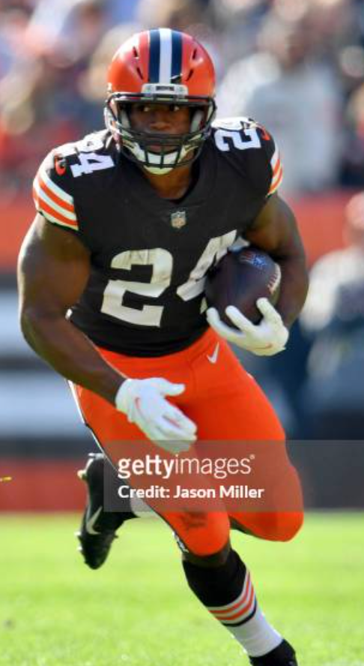

Good work-recent news-they are saying only his MCL tore-wild!!!!
100/100

